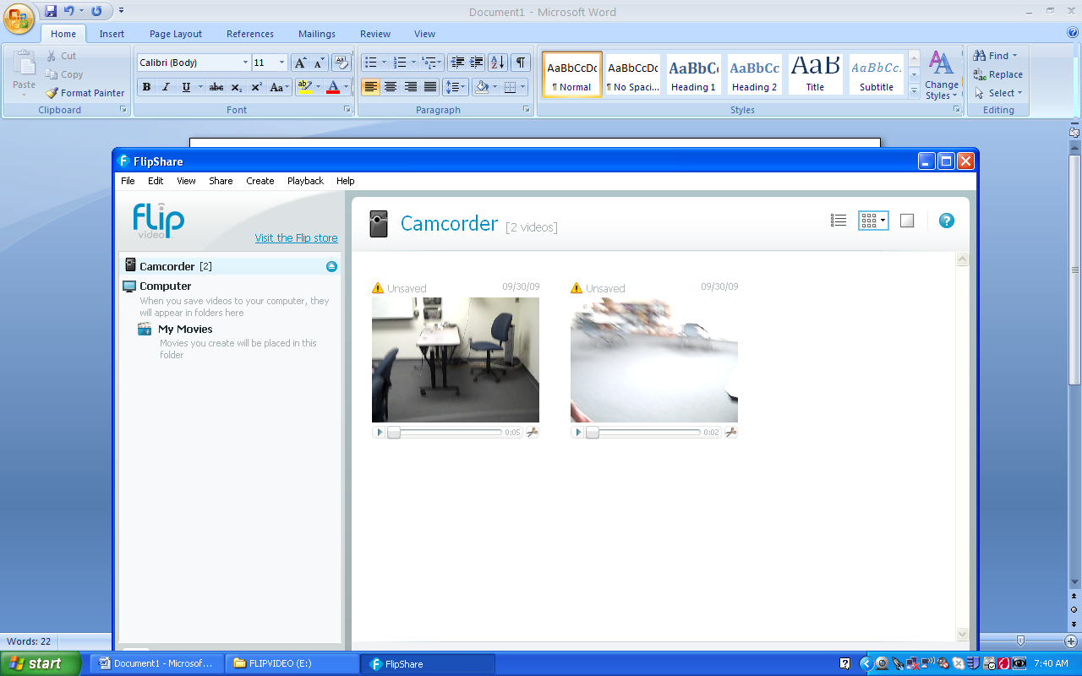
Directions for Video Conversion using Any Video Converter
Plug in your Flip Camera. If it opens the following window, just close it.
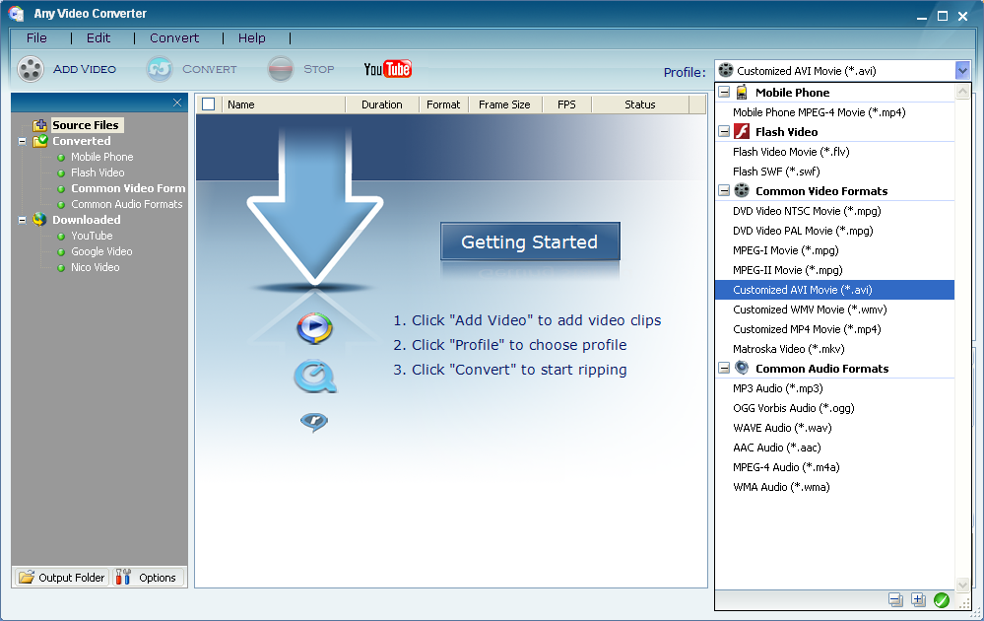
Open Any Video Converter.

1. Go to the File menu and select Set Output folder. This will determine where your converted files go. Use the folder you will be saving your MovieMaker project into.

2. Go to the Profile dropdown menu in the upper right hand corner and select Customized AVI Movie.

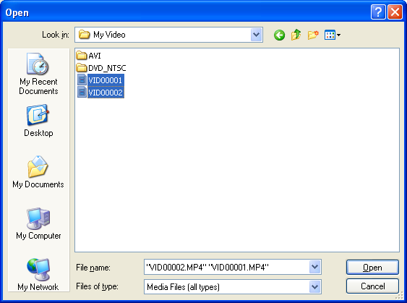
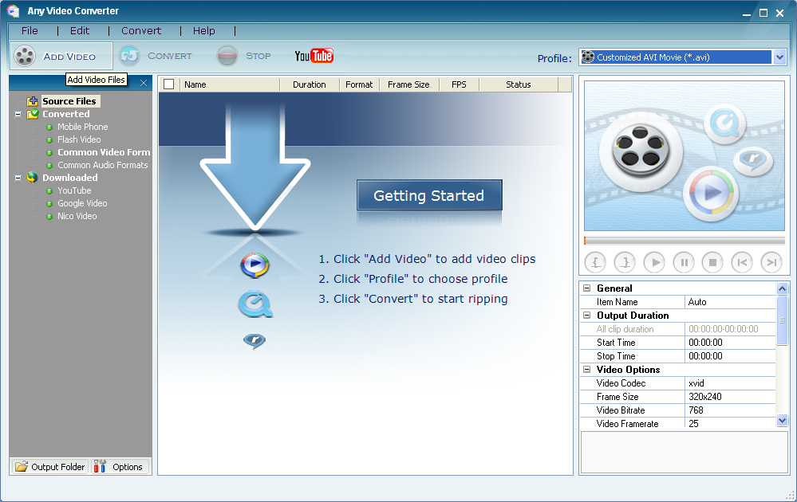
5. Browse to find your video files on your camera. (Go to My Computer/Flip Video/DCIM/100Video).
Select all your video files by doing Select All, or holding the Control Key down while you select each video file.
4. Click Convert
3. Click Add Video

6. Select Open.

Your files will be converted and placed in a folder titled AVI inside the folder you selected as your output folder.

